GREEN — Operations Practice Questions
Syllabus points: 1. Sequencing and scheduling · 2. Outputs · 3. Outsourcing · 4. Technology (established and leading edge). Questions are unchanged, exactly as they appear in the original papers.

1. Sequencing and scheduling
2021 HSC — Question 21 (b) (4 marks)
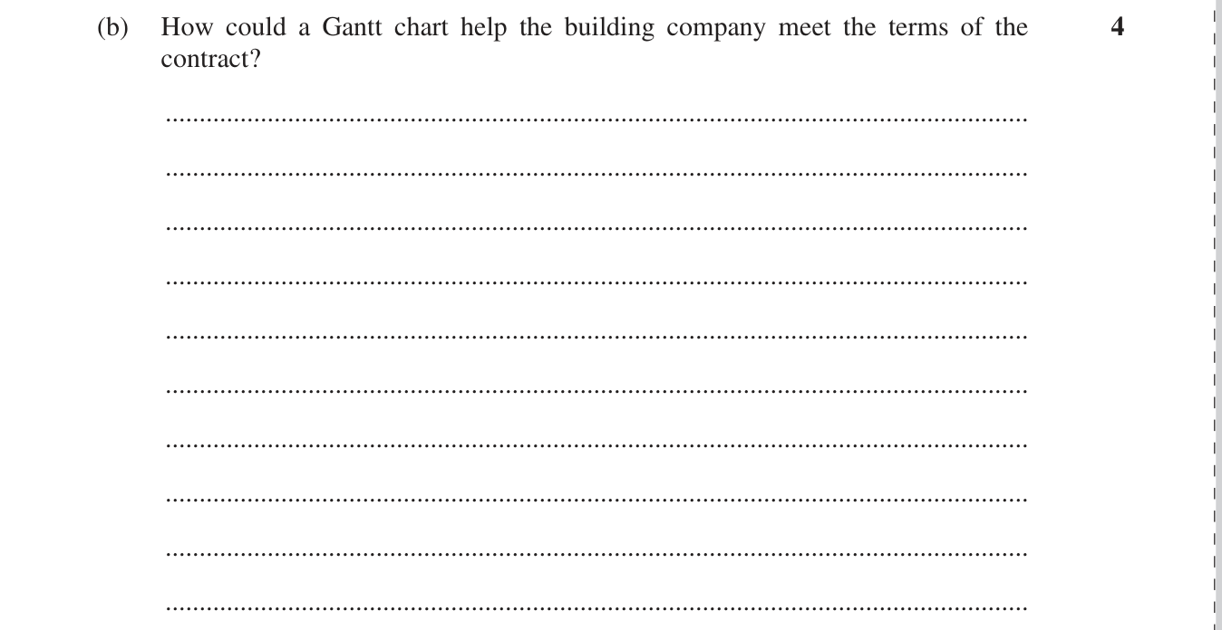
Reddam Trial 2024 — Question 21 (c) (3 marks)
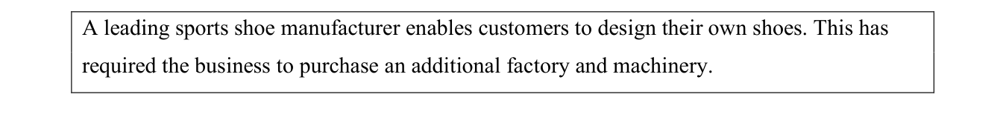
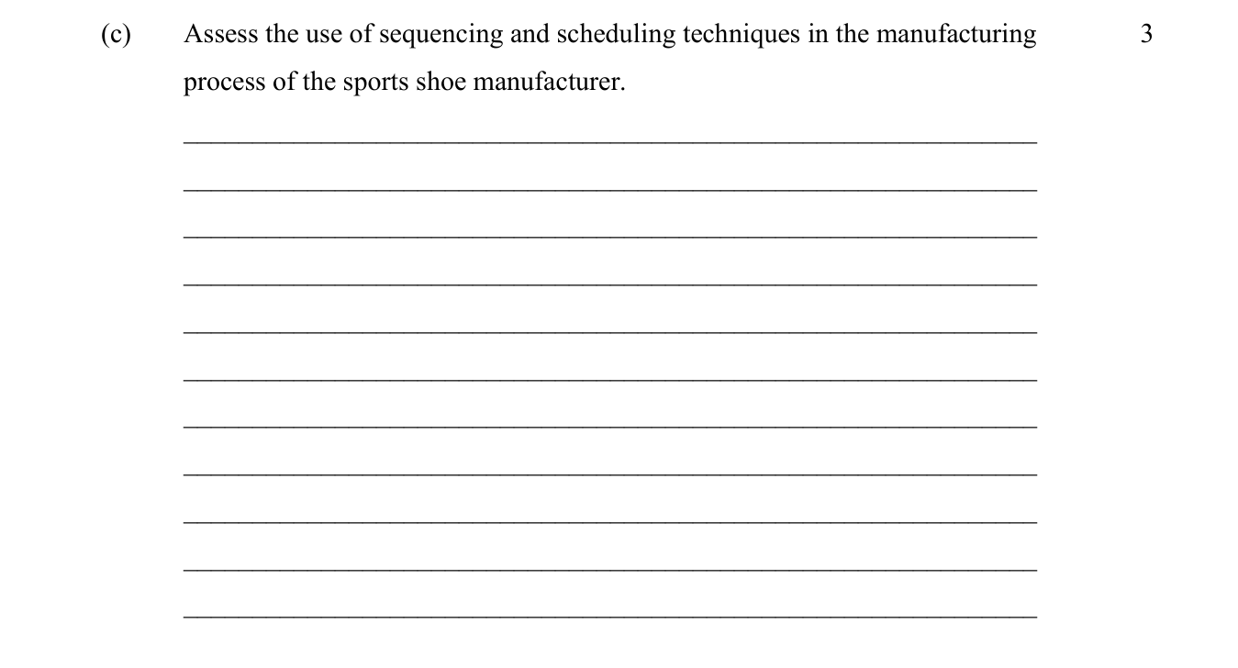

2. Outputs
Reddam Trial 2023 — Question 21 (c) — warranties (2 marks)
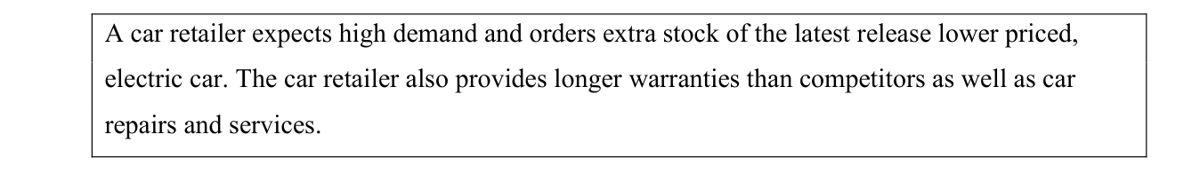
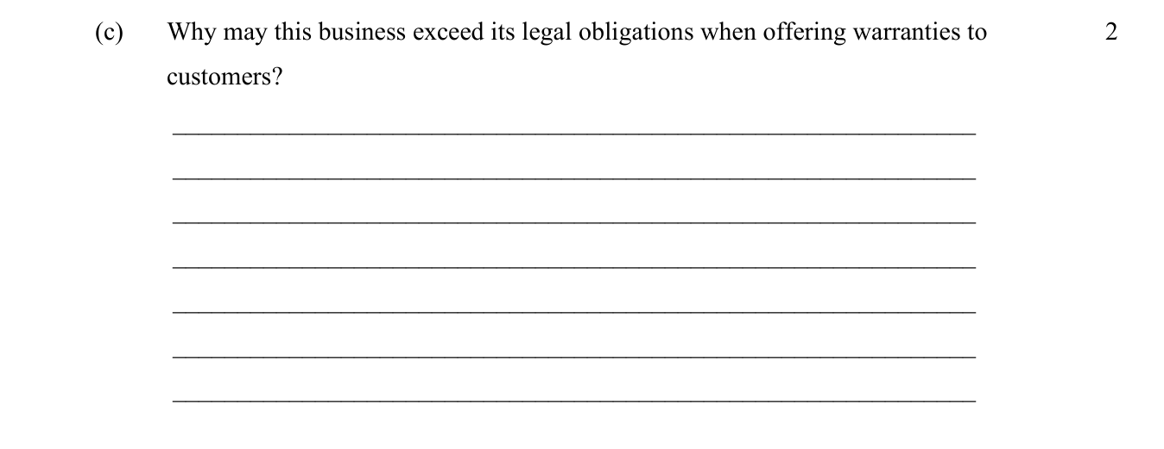

3. Outsourcing
2021 HSC — Question 21 (c) — quality management of outsourced work (4 marks)
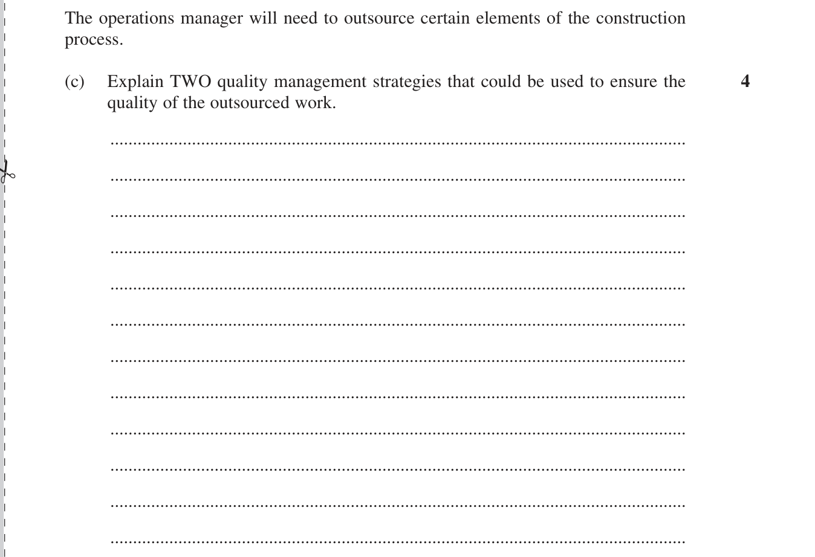

4. Technology — established and leading edge
SIC Trial 2024 — Question 21 (c) (4 marks)
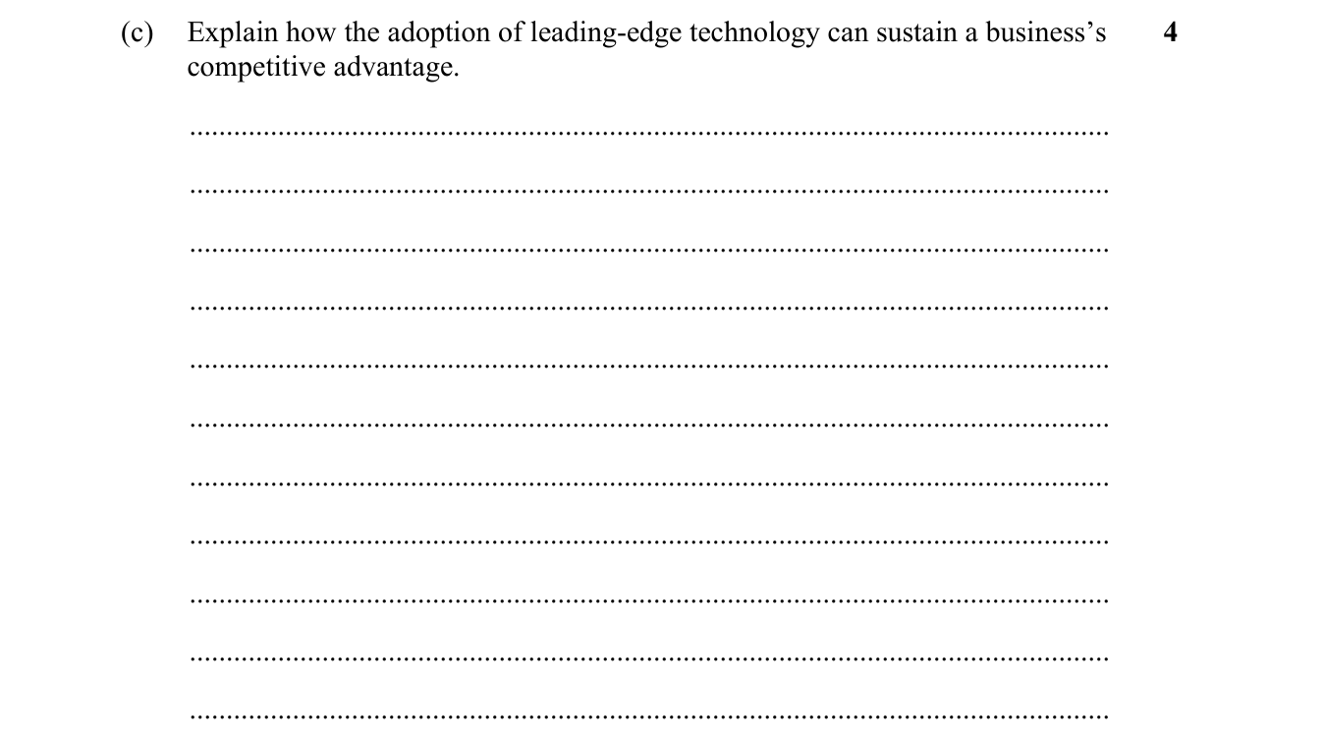
Barker Trial 2024 — Question 22 (c) (5 marks)
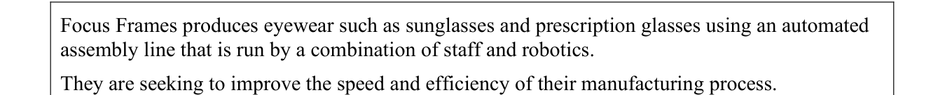
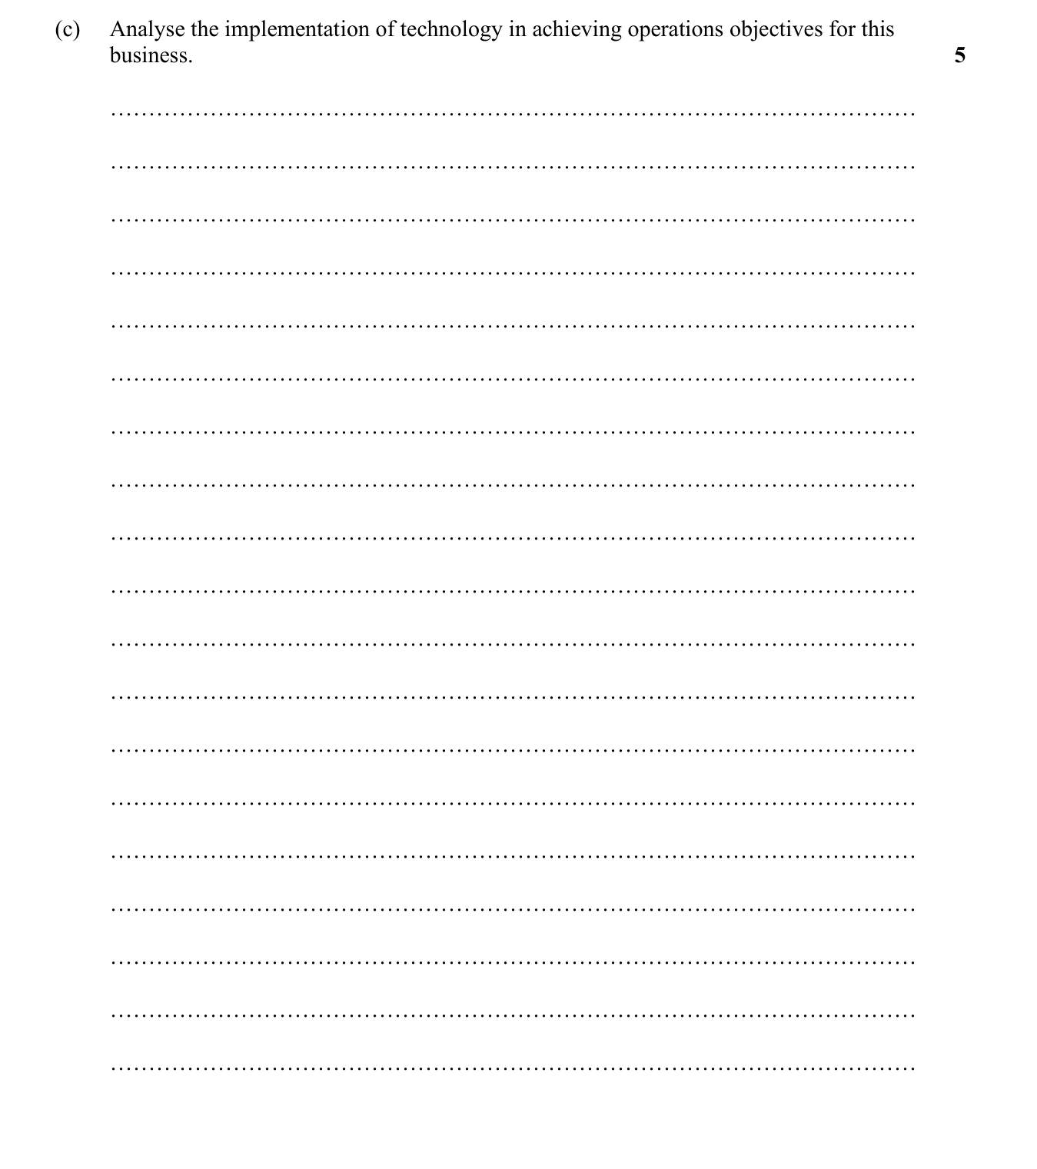

Multiple Choice
2019 HSC — Q13 — Gantt chart (1 marks)
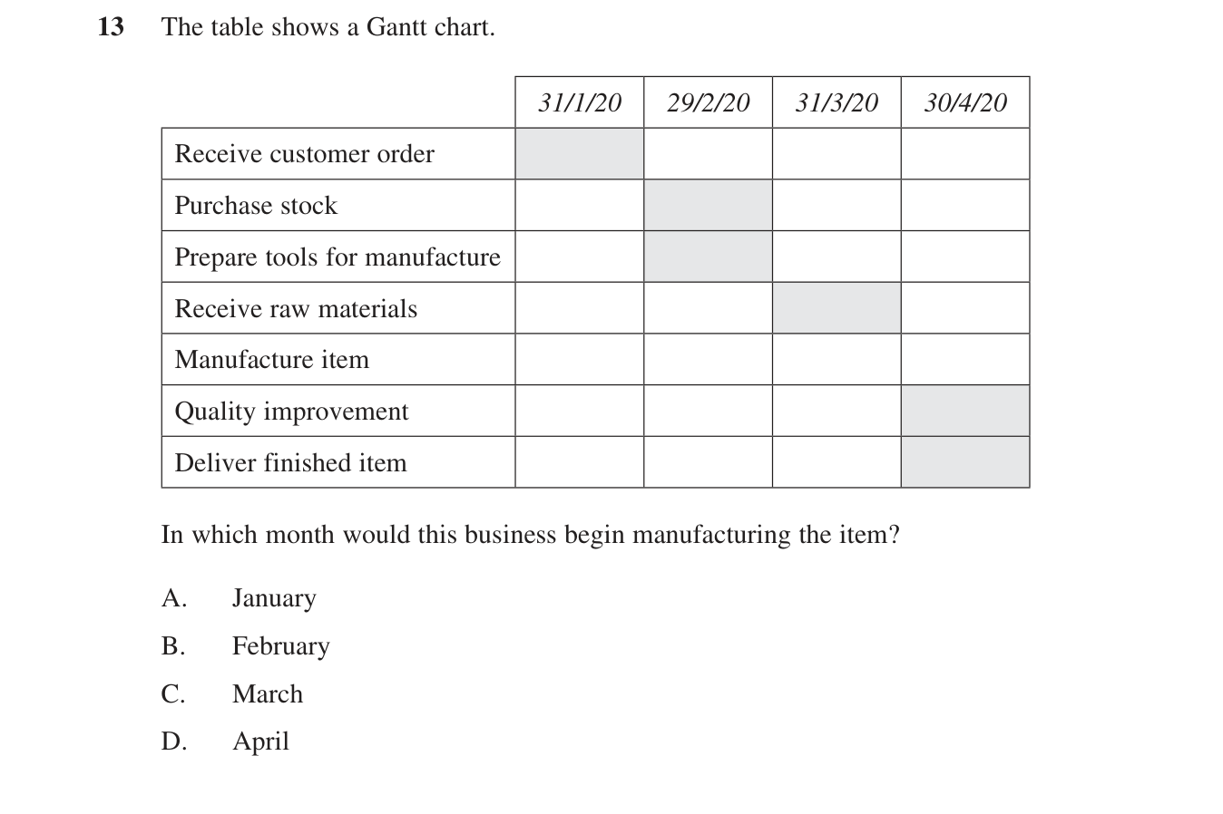
Abbotsleigh Trial 2024 — Q13 — outsourcing (1 marks)
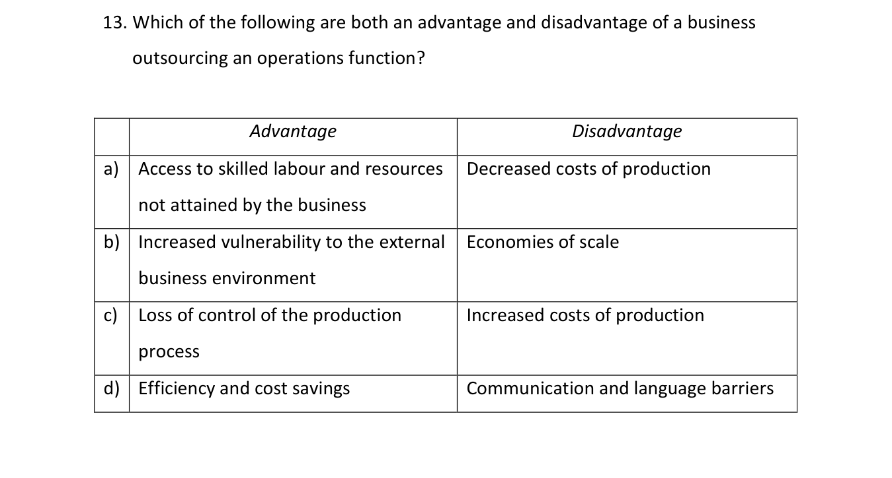
2021 HSC — Q3 — established vs leading-edge technology (1 marks)
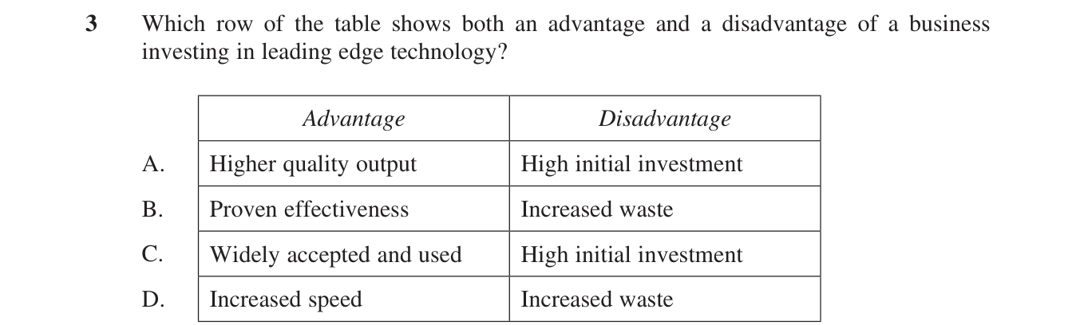

Extended Response
All operations extended responses from your papers that hit GREEN points (business reports excluded).
Roseville Trial 2023 — Question 26 — supply chain management & outsourcing (20 marks)
